William Smith O'Brien (1803 –1864) was an Irish Nationalist Member of Parliament (MP) and a leader of the Young Ireland movement. Although he was a Protestant, he actively favoured Roman Catholic emancipation. He was the second son of Sir Edward O' Brien 4th Baronet of Dromoland Castle, Co. Clare. He was a descendant of the eleventh century Ard Ri (High King of Ireland) Brian Boru. He received an upper-class English education at Harrow School and Trinity College, Cambridge. Subsequently, he studied law at King's Inn in Dublin and Lincoln's in London. He was a cousin of the Ffrench's of Monivea Castle.
William Smith O' Brien was convicted of high treason and was sentenced to death for his part in the "Famine Rebellion of 1848". The William Smith O'Brien petition was initiated throughout Ireland and the UK to plead for clemency for O'Brien. Below is a list of people from Monivea who signed the 1848 petition. Following the petition his sentence of death was commuted to deportation to Van Diemen's Land (1849). In 1854, he was released from Van Diemen's Land on the condition of never returning to Ireland. In 1856 Smith O'Brien was pardoned and returned to Ireland, but he was never again active in politics.
Information from: myHeritage, Findmypast.ie, National Archives of Ireland, Wikipedia.
To Her Most Gracious Majesty Victoria Queen of Great Britain and Ireland.  We the undersigned inhabitants of the Parish of Monivea in the County of Galway most humbly supplicate your most Gracious Majesty to extend Your Royal Clemency to W.S. O' Brien.  2nd Nov 1848 | 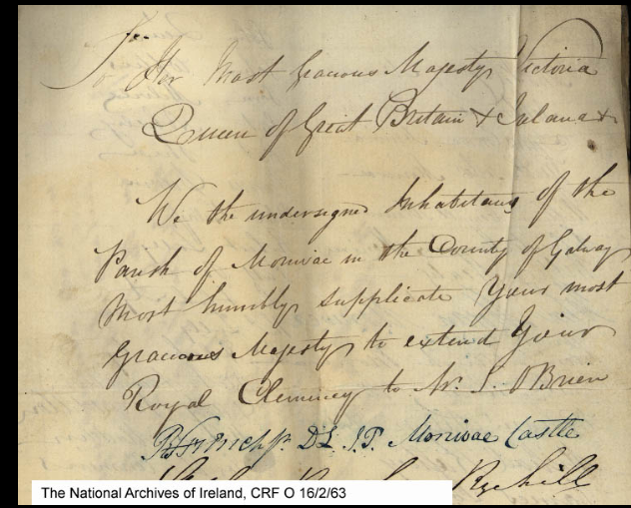

Name | Name | Name
Robert French D.L J.P, Monivea Castle | Michael Raftery | Pat Rooney
Stephen Roache, Ryehill | James Junr Loftus | John Flaherty
Peter Blake, Crumlin | Thomas Loftus | Thos Tully
Geo Powerin | Michael Loftus | Ml Flaherty
Rchd Maxwell, Clerk | Patt Rafterry | Pat Scandillion
Digby French M.D. | Pat Madden | Darby Scandillion
George French | John Madden | Michael Madden
Thomas J. Crowe | Robert Madden | Joseph Conmins
John Crowe | Mathias Ward | Ellias Cosgrife
James Crowe | Pat Davan | John Murphy
Richard Costello | John Quin | James Bane
William Connell | John Loftus | James Bevines
Silvester Cummins | Tom Milvile | Mark Coen
William Healy | Pat Nohely | Patt Fahey
John Moran | Pat Shea | Michl Rourke
Thomas French | James Davin | John Tynne
Patk Allen | Peter Tully
William Allen | Robert Tully

